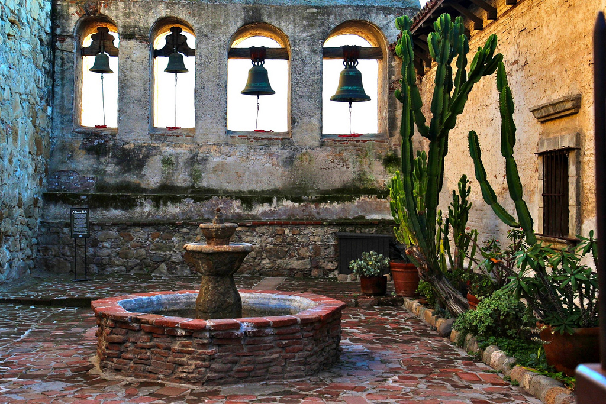

I liked this photo because it reminded me of a painting. It may not have any human subject manner, but there are so many varying areas of light and color that it becomes interesting to look at. In addition to this there are numerous textures that make you feel as though you are there. From the smooth stone floor to the rough sandstone and mortar walls to the sharp cacti growing in the garden there is amazing contrast throughout this piece. The bells hanging in the windows almost make you hear a tune chiming through the air at noon, and the lack of a working water fountain causes you to sit back and imagine what this would look like with another detail. Would it have made it a better image or hindered it in some way?